Flowcharts and Algorithms

**1 Star pyramid type 1:**

*

* *

* * *

Algorithm:

1 Start the program

2 Initialize an integer variable a=1and num

3 Ask the user to enter the number of rows they want store it in num variable.

4 repeat steps 4 to 10 until r<=num

5 initialize a variable int i=1

6 repeat the steps from 6 to 8 until i<=r

7 print *

8 i++

9 go to next line

10 r++

11 stop

Start

Int a=1

Int num

If r<=num

Enter an integer

Int i=1

I<=r

*

I++

Go to new line

R++

end

**2 Star pattern type 2:**

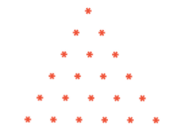

Algorithm

1 start the program

2 declare integer variables a and b

3 input the number of rows, store it in a

4 b=a

5 initilaize int i= 1 and int j=1 and int k=1

6 repeat steps 6 to 12 until i<=a

7 repeat steps 7 to 8 until j<=b

8 print a space

9 repeat steps 9 to 10 until k<=2*i-1

10 print *

11 b—

12 go to next line

13 stop

start

Declare the integer variables a and b

Input an integer a

b=a

i=1, j=1, k=1

I<=a

J<=b

K<=2*i-1

*

b--

Go to next line

End

**3 Number pattern- half pyramid:**

**1**

**23**

**456**

Algorithm

1 Start

2 Initiliaze int i=0, int j=1 and int num=1

3 Repeat steps 3 to 7 until all conditions are true

4 repeat steps 4 to 7until i<num

5 repeat steps 5 to 7 until j<=i

6 print num

7 num++

8 end

start

Int i=0, j=1, num=1

I<num

J<=i

num

Num++

I++, j++

+

start

**4 Number pattern:**

**11111**

**11111**

**11111**

Algorithm

1 Start

2 declare integer variables rows, i=1, j=1

3 here we have to print 5 times ‘1’ in a row

4 repeat steps 4 to 7 until i>= rows

5 repeat steps 5 to 6 until j>=5

6 print 1

7 go to a new line

8 end

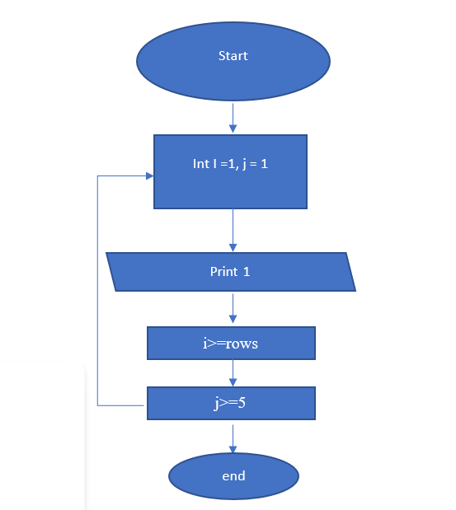

**5 Alphabet pattern type 1**:

E

DE

CDE

BCDE

ABCDE

1 Start the program

2 declare the variables int i, j, n

3 Ask the user to enter the number of lines, store it in n

4 i= n

5 repeat step 5to 8 until i>=1

6 repeat steps 6 to 7 until j<=n

7 print the character (j+64)

8 go to another line

9 end

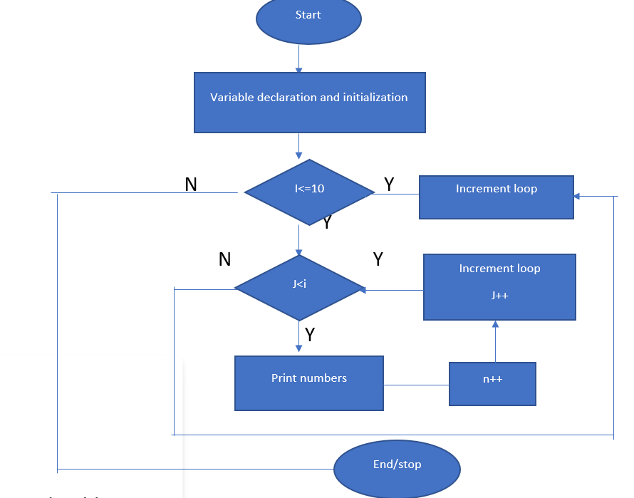

**6 Alphabet pattern type 2:**

**A**

**BB**

**CCC**

Algorithm:

1 Start the program

2 declare integer variables i, j, n

3 ask the user to enter number of lines and store it in n

4 i=1, j=1

5 repeat the steps 5 to 8 until i<=5

6 repeat steps 6 to 7 until j<=i

7 print character (j+64)

8 go to next line

9 end

start

Declare int i=1, j=1, num

Print character j+64

End

J<=i

I<=5

Input num